ICT Meeting Notes 2020/21

# Monday 5th October

#### Performance Management

<https://docs.google.com/document/d/19kMLVLOgSWQ6Cqmb1N2jjiGODUZQiOpXRBGo0t_Gqik/edit?usp=sharing>

#### Planning

-Time to tidy it up

#### Hour of Code - Robotics Parents Workshop

LD to organise

#### Code Competition

#### Bebras - Talk to Andy and john

<http://www.bebras.uk/>  
Davis Knags has the information & School Registration

#### Working in Room

-

AOB

# 

# Monday 31st August

#### Google Photo Folder - <https://photos.app.goo.gl/68Vs7VCPaq9dj2NeA>

Add any photos that you take here - the more the merrier

#### Planning

Where, When, What etc…  
When do we want it pretty by? Any Suggestions of how to make it more effective, usable, pretty or just better?

F3 - Beebots - Luke and Maria  
Year 1 - Beebots then Puppet Pals then Scratch Jr (Luke to write up Beebots and P/Pals - Anthony Scratch Jr)

Year 2 - Photography another lesson then Dash (Maria to write up)  
Year 3 - WeDo & Sites (Anthony to plan both) - 2 X 3 weeks

Year 4 - Keynote Storytelling (Luke) & Scratch Maze (Maria) 2X 4

Year 5 - EV3 (Luke) & Coding Choose Your Own Adventure Game (Maria)​ 2x5 weeks

Year 6 - 3D Printing (Luke) & Documentary (Maria) 2 x 5 weeks

#### Communication with Students

Google Classroom   
- What does it look like?  
-Adding each other into one of each others classes for each year level   
SeeSaw   
- Year 2 is rocking, but what about the rest and what does it look like?  
-What are the expectations from Management/SMT?

#### Next Units - A and B units - Or ABC?

Yr 3 A  
Yr 3 B  
Yr 4 A  
Yr 4 B  
Yr 5 A  
Yr 5 B  
Yr 6 A  
Yr 6 B

#### Assemblies - Dates

1 & 2 Luke  
3 & 4 Anthony  
5 & 6 Maria

#### EY&I - Target for ICT this year

Look for readings, Blogs, Experts on Twitter… We are really resourced and have the autonomy, so how can we make it awesome, innovative and creative?  
What has worked so far? WWW  
AREs in Yr 1 & 2 - what do the hit and what do they miss?  
Developmental Matters - F3 Curriculum

# Wednesday 12th August

* Timetable  
  <https://docs.google.com/spreadsheets/d/155PP_tNRS7IARSwNbXmyTihXIwN8PC_dl040Gd6p8SU/edit?usp=sharing>
* Websites - Updated for 2020/21  
  <https://sites.google.com/bisvietnam.net/primaryict202021/home>
* ICT Calendar - Not much to be added this year, but if there is we should add now
* Digital Citizenship - Maria  
  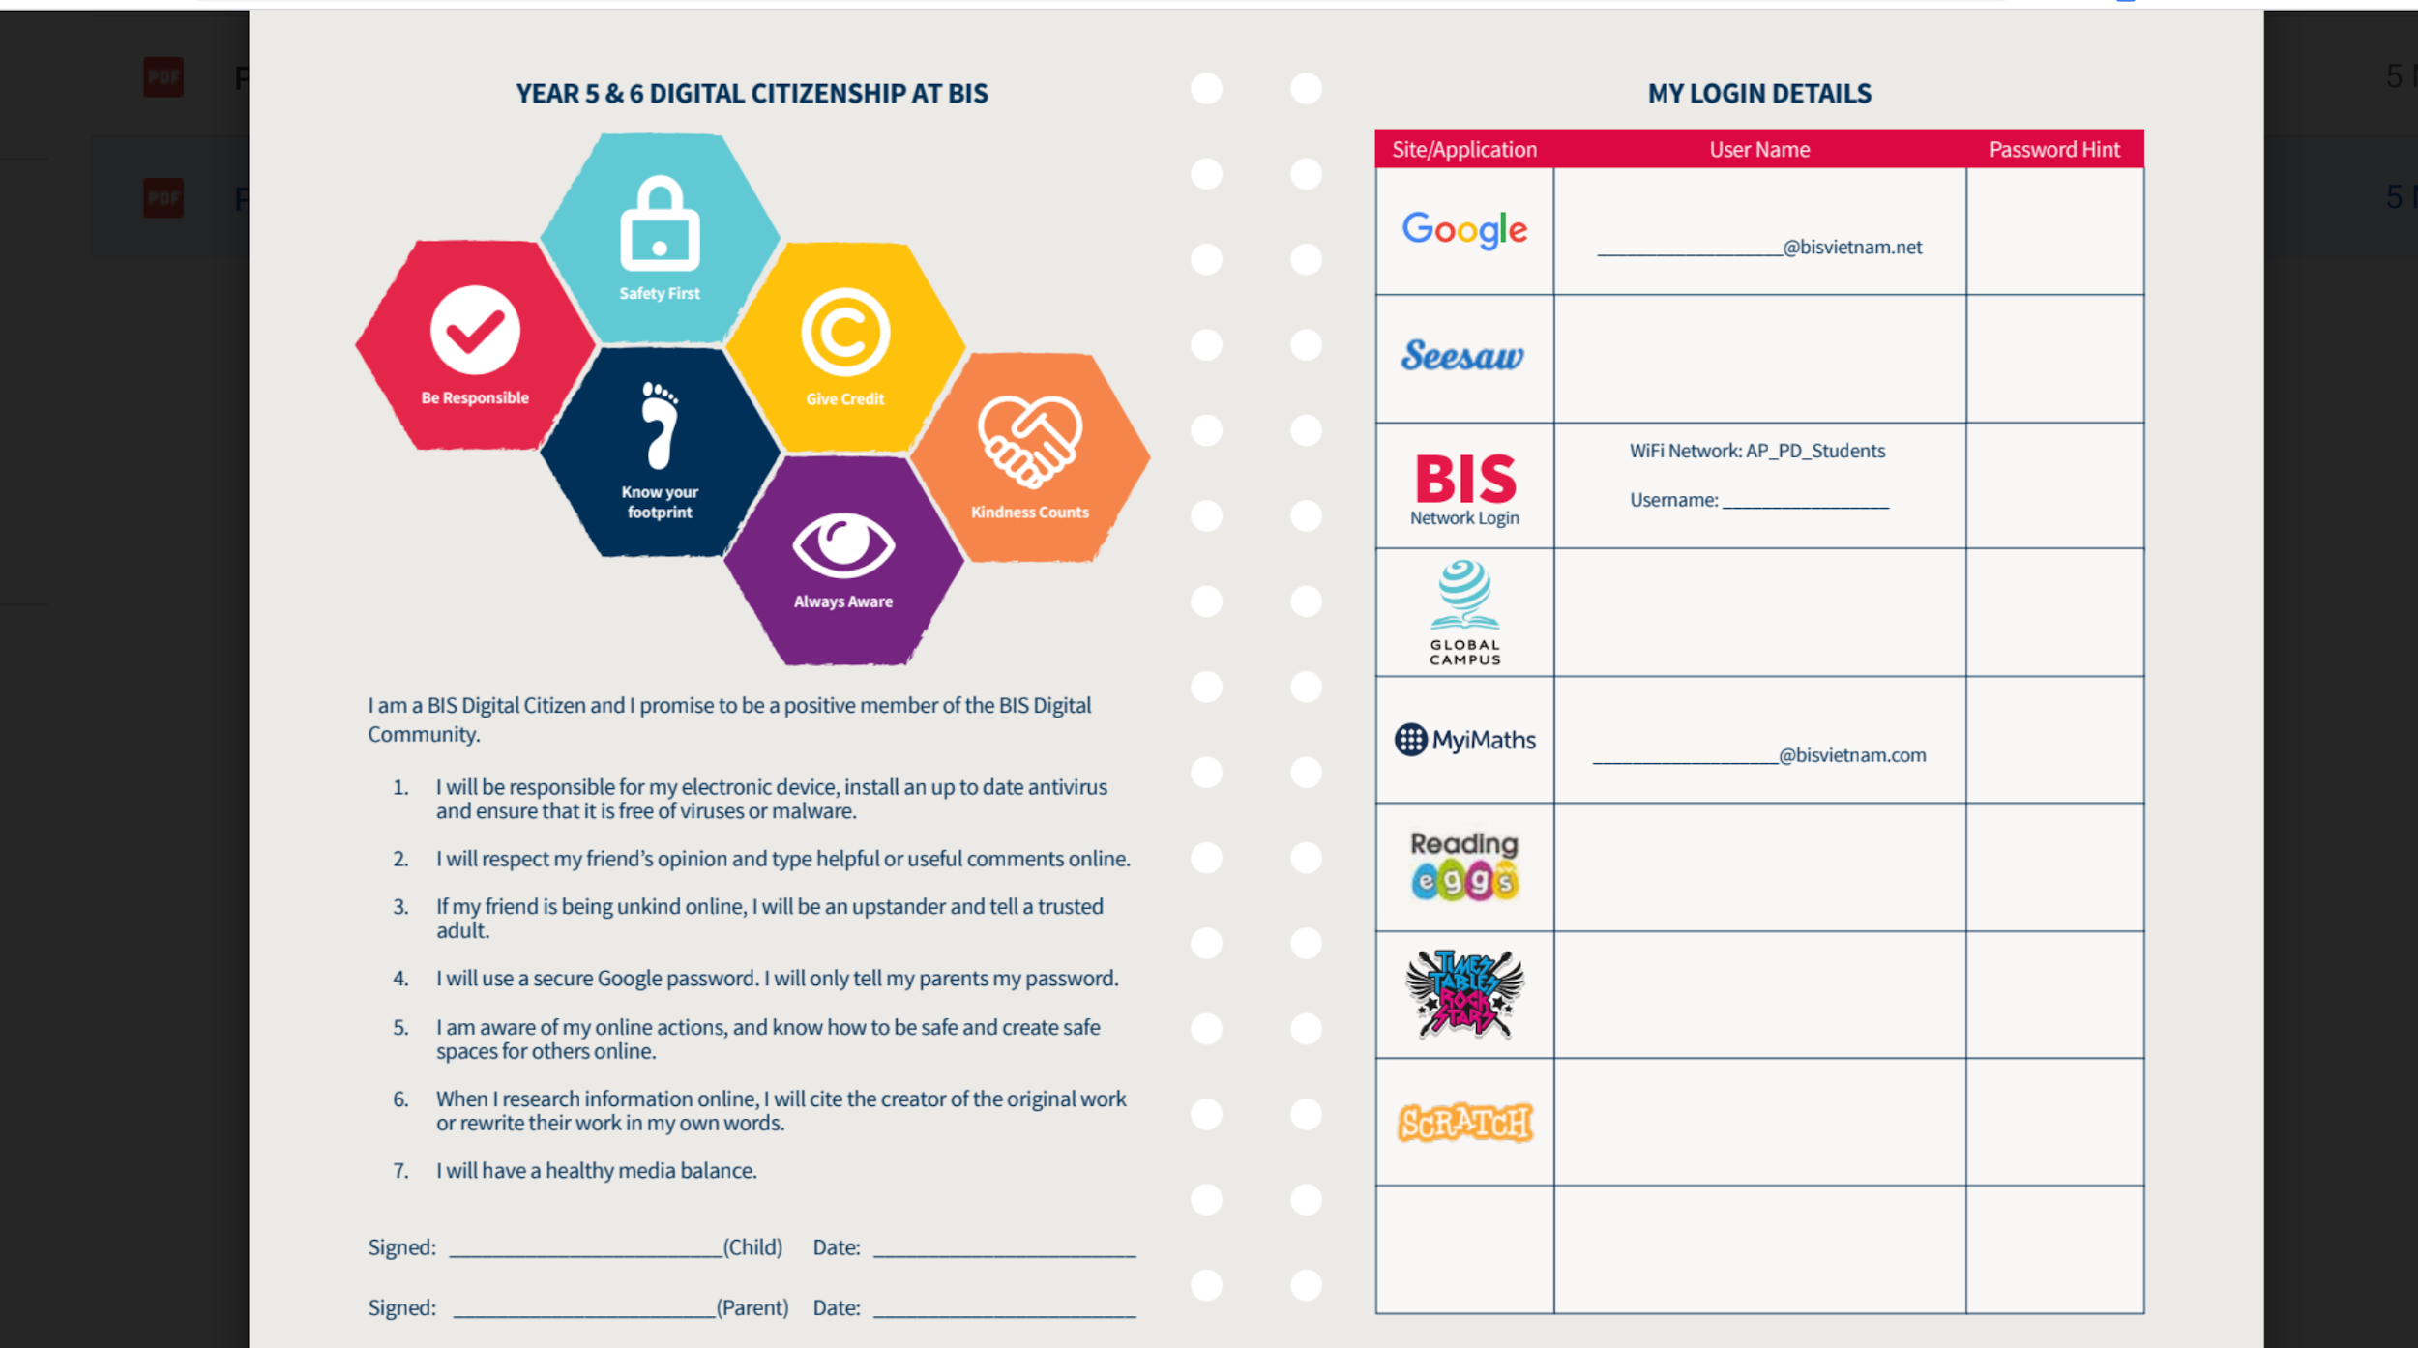

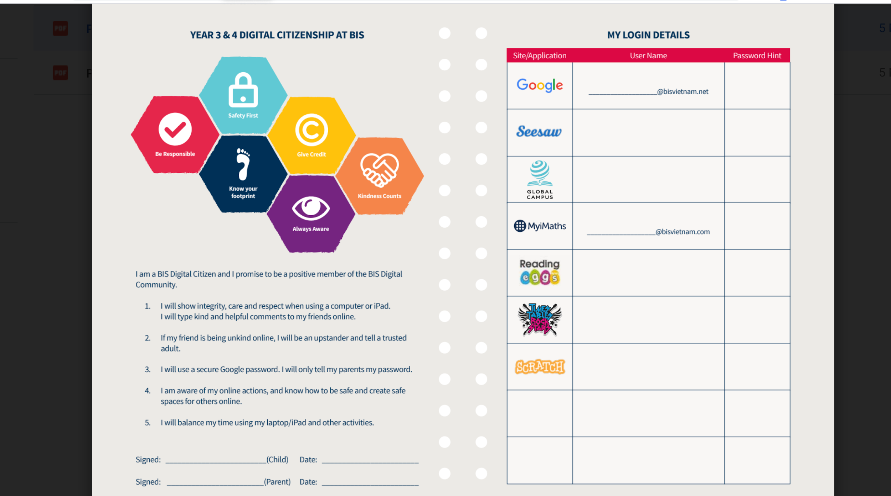

* Progression of units for the first Term - What classes are learning what and when?  
  <https://docs.google.com/spreadsheets/d/1H2KzTr-cTfhvtMhLqsjTLyAcDEgrE_9sw7f-WlZA6kE/edit?usp=sharing>
* Classroom Setup  
  Inventory - update  
  Clearing of clutter  
  Labeling of Resources  
  Sending Back Resources that we do not need   
  ...cleaning supplies
* Devices  
  Organisation & Setup  
  <https://docs.google.com/document/d/1kSBNPyC-bulUWKm28Gdfa46hTZ8HRJRY0VEXlVYCPTg/edit?usp=sharing>
* Team Meeting time  
  -Not a possible time for all of us to meet, but Tuesday mornings for M A & L
* Events  
  There will not be any out of HCMC Opportunities for our students, so can we make some happen in HCMC?  
  -Code Competition (could include KS3 and could include other International Schools like ISHMIC, TAS, UIS, SSIS & AIS)  
  -As above, but Robotics? Robot League?

* Things that we need to get sorted incase of another Virtual Classroom
* Planning   
  Sharing the load and what it should look like  
  Document Format - does it need a change?  
  Do we need to make a student version?  
  Google Slide for each Unit - Is this working?  
  <https://docs.google.com/document/d/1Zkyd3otl15iZFLtYm5o7LL8QIiaz1oN0W2zBp6DVmb4/edit?usp=sharing>
* Department Focus/Target - EY&I Curriculum - F3 to Year 2  
  An area that needs to be focused on for the next 6 months  
  Key learning skills and dispositions  
  Do the AREs match and what are the F3 AREs
* Social Media…   
  <https://docs.google.com/document/d/1Wz7H96zwV7OSV31bhu__ZT5EbZ1ujf8_PrvYbFvmP8g/edit?usp=sharing>
* **To be looked at later**  
  Tracking and assessment - Especially with Year 5&6